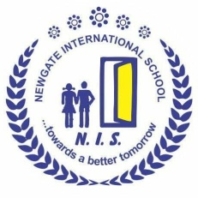
NEWGATE INTERNATIONAL SCHOOL

12, Apena Jimbo Street, Ebute - Ikorodu Lagos State.

Tel: 08023215477

SECOND TERM MID TERM QUESTION 2025/2026 SESSION

CLASS: NURSERY 1 Name of Pupil :
RECOGNITION OF LETTERS
Hello my sunshine’s, I am sure you had fun this six weeks of resumption. Let’s do this. Show mummy and daddy what you have learnt in our letter class. Identify and read these tricky words to mummy and daddy correctly
lo
DO
So
My

by
go
he
to


no
go
be
lo
up
he
so
us
be
to
he
go
by
so
my
no

NUMBER WORK
Let’s flash back on all we have done this term as you answer the following question. Count and add these numbers together

7 + 4 = 5 2
5 + 3 = + 1 + 2
6 + 4 =
7 + 2 =

Now kids, lets identify and circle out take away sign (-)

÷
+
=
-
>
<
x
∕
-
x
+
√
-
÷
<
=
-
+
√
>

Recognition of Numbers
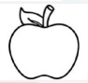
Let’s recognize our numbers to daddy happily
25
26
30
40
20
19
37
39
33
50
37
28
45
24

SCIENCE
Color makes me happy everywhere I go, the world is like a rainbow putting up a beautiful show oh putting up a beautiful show ohoooo
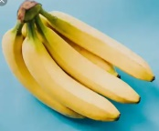
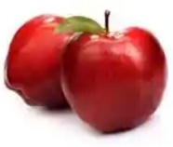
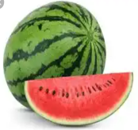
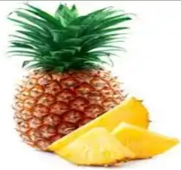
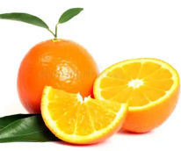
1. Now look at the colours below, let’s recognize some of the rainbow colours to daddy.

2. Fruit fights gems and diseases in our body and it makes us strong and healthy every day.
Hello children, lets identify these fruits to mummy.

SOCIAL STUDIES
1. Whoa! it had been fun learning how to sing our school anthem.
My little prince and princess, lets demonstrate as you sing your school anthem to mummy;
Newgate international school
Our School of learning……………..
2. Food makes us grow and healthy. Hello children, lets mention different types of food we have to daddy.
Writing
My | by
RHYMES
Mary had a little lamb
What should we do with all the coins we found?

Hey diddle, diddle

