
NEWGATE INTERNATIONAL SCHOOL

12, Apena Jimbo Street, Ebute - Ikorodu Lagos State.

Tel: 08023215477

SECOND TERM MID TERM QUESTION 2025/2026 SESSION

CLASS: TODLER ROCK Name of Pupil: __________________________

Wow!!! It’s been an amazing time this half term. Now let’s have fun and show dad and mum what we’ve learnt this term. Hello jewel show your skill to mum and dad as you sound and color


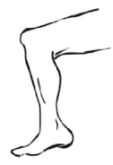



It’s been fun sounding our letters
Now sound and demonstrate to mum and dad as you match the letters to its objects and color the letter and the objects

Hold your pencil in a grip hold as you sound and trace these letters neatly and carefully

Number Work
Counting time, fun time let’s have fun as we jump and count our numbers from 1- 15
1 2 3 4 5 6 7 8
9 10 11 12 13 14 15
Now trace out these numbers neatly.

Oh yeah! I can do it on my own. Identify and match these numbers.
0 3
1 2
3 0
SCIENCE

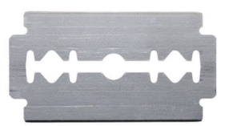


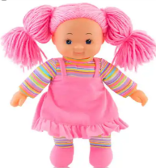

We must stay away from sharp objects to prevent accident at home and in school. So, mummy lets guide our jewels to stay away from danger as we color the objects we should stay away from.

SOCIAL STUDIES
Our social studies class was great
We have learnt that food makes us grow. Now show mummy and daddy as you color the thing we eat




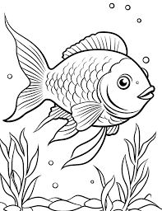



RHYMES
Yeah! We are always rocking our class with interesting rhymes. Mummy and daddy sit back and hear us sing
Hello, hello, hello how are you?..........................
Can we share mmmmmmm
We can share mmmmmmm
Please ok ……………..
The wheel on the bus goes round and round…….it goes round and round

Dear parents, kindly comment on your child/ward’s performance.

Parents comment: _________________________________________________________

__________________________________________________________________________

Performance Rating: Excellent Good Fair Performance Rating:

Performance Rating: Excellent Good Fair

